**Corvette Club of Delaware Valley – 2024 Cavalcade**

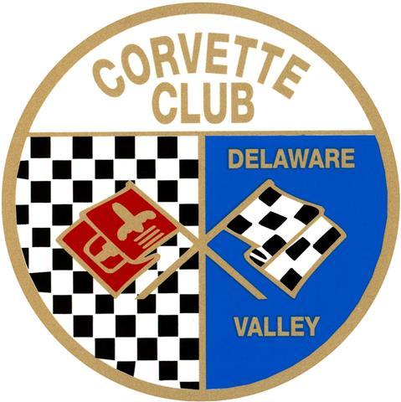

**Awards Results**

Special Awards

* Best in Show - V43 Denise Bodnar, 2017 C7 Convertible – Easton, PA
* Veterans Choice - V21 Austin Hodges, Jr, (Navy) 2003 C5 Coupe – Erial, NJ
* Bryner’s Choice - V60 David Jannone, 1966 C2 Coupe – Pittstown, NJ
* MBIT Choice - V70 Steve Strzemek, 1967 C2 Convertible – Ambler, PA
* Sunshine Foundation - V75 Thomas Laroche, 1954 C1 Convertible – North Wales, PA
* Kids Choice - V37 Dan Citron, 2024 C8 Coupe – Fords, NJ
* Best License Plate – V66 Ernest Reed, 2019 C7 Coupe – Philadelphia, PA
* Top Participating Club – Corvettes on Patrol

C1 - C8

* C1 Stock

First Place – V54 Rich Cirminello, 1962 Convertible – Monroe Township, NJ

Second Place – V64 Steve Lear, 1961 Convertible – Sellersville, PA

Third Place – V59 Jeff Pizzuto, 1959 Convertible – Allentown, PA

* C1 Modified

First Place – V27 Jim Chaney, 1956 Convertible – Jamison, PA

* C2 Stock

First Place – V63 Ron Levy, 1967 Convertible – Warwick, PA

Second Place – V18 Jeff Davis, 1967 Convertible – Yardley, PA

Third Place – V34 Alan Bove, 1967 Coupe – Doylestown, PA

* C2 Modified

First Place – V13 Timothy Mosser, 1964 Coupe – Warrington, PA

Second Place – V77 Bill O’Brien, 1963 Coupe – Abington, PA

* C3 Stock

First Place – V48 Edward Falcone, 1979 Coupe – Horsham, PA

Second Place – V72 Jim Brooke, 1969 Convertible – Blue Bell, PA

Third Place – V32 John Fasano, 1971 Convertible – Newtown, PA

* C3 Modified

First Place – V24 Jeff Nonnemaker, 1973 Coupe – Allentown, PA

Second Place – V79 David Eisenberg, 1977 Coupe – Hainesport, NJ

* C4 Stock

First Place – V7 Dave & Pauline Molettiiere, 1988 Coupe – Quakertown, PA

Second place – V58 Barry Grife, 1995 Convertible – Doylestown, PA

Third Place – V78 Rich Robertson, 1991 Coupe – Telford, PA

* C4 Modified

First Place – V40 Bill & Mary Elmore, 1994 Coupe – Bordentown, NJ

* C5 Stock

First Place – V28 Bruce Garnto, 1998 Coupe – Emmaus, PA

Second Place – V4 John Bertolotti, 2003 Coupe – Brick, NJ

Third Place – V47 Dennis Hallowell, 1998 Coupe – Whitehall, PA

* C5 Modified

First Place – V21 Austin Hodges Jr, 2003 Coupe – Erial, NJ

Second Place – V12 Bruce Shoemaker, 2003 Coupe – Hatboro, PA

* C6 Stock

First Place – V46 Bob Bernhardt, 2006 Convertible – Easton, PA

Second Place – V65 Stephen Lapp, 2010 coupe – North Wales, PA

Third Place – V55 Joe Boris, 2009 Coupe – Croydon, PA

* C6 Modified

First Place – C49 Tony Abarno, 2008 Coupe – Millstone, NJ

Second Place – V9 Thomas Manz, 2005 Coupe – Helmetta, NJ

Third Place – V67 Anthony Clement, 2006 Coupe – Philadelphia, PA

* C7 Stock

First Place – V36 Michael Tulio, 2019 Convertible – Doylestown, PA

Second Place – V66 Ernest Reed, 2019 Coupe – Philadelphia, PA

Third Place – V6 Nick Orlando, 2015 Convertible – Jackson, NJ

* C7 Modified

First Place – V16 Robert Hee, 2019 Coupe – Chalfont, PA

Second Place – V8 Bob Lundgren, 2014 Coupe –Collegeville, PA

* C8 Stock

First Place – V42 Mark Dressel, 2022 Convertible – Easton, PA

Second Place – V26 Bobby Hartwell, 2022 Coupe – Collegeville, PA

Third Place – V2 Dennis Spaulding, 2023 Convertible – Millsboro, DE

* C8 Modified

First Place – V44 David Hausman, 2024 Coupe – Bethlehem, PA

Second Place – V20 Ruth Rohach, 2022 Coupe – Turnersville, NJ

Third Place – V37 Dan Cintron, 2024 Coupe – Fords, NJ

Participants Choice – Top 10 CCDV Vehicles

* C24 – Leroy Bilmegger – 1968 C3 Convertible
* C13 – Russel Thomas – 1958 C1 Convertible
* C37 – Joe Archutowski – 2003 C5 Z06 Coupe
* C9 - Al DePue – 2014 C7 Coupe
* C5 – John Crawford – 1998 C5 Convertible
* C33 – Rick Bagshaw – 2021 C8 Coupe
* C36 – Stanley Fisher – 1967 C2 Convertible
* C40 – Dennis Matlack – 2014 C7 Convertible
* C41 – Robert Van Houten – 2015 C7 Coupe

***Note*** – Only received enough votes for nine awards.

**Total Registrations – 142**

* Visiting Participants – 81
* CCDV Members - 61